Create a React Application named “ticketbookingapp” where the guest user can browse the page where the flight details are displayed whereas the logged in user only can book tickets.

The Login and Logout buttons should accordingly display different pages. Once the user is logged in the User page should be displayed. When the user clicks on Logout, the Guest page should be displayed.

**Directory:**

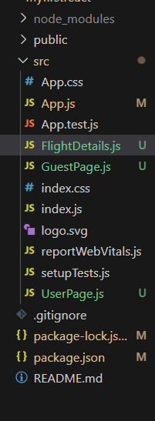

**Code for App.js:**

import React, { useState } from 'react';

import UserPage from './UserPage';

import GuestPage from './GuestPage';

const App = () => {

  const [isLoggedIn, setIsLoggedIn] = useState(false);

  const handleLogin = () => setIsLoggedIn(true);

  const handleLogout = () => setIsLoggedIn(false);

  return (

    <div style={{ padding: '20px', fontFamily: 'Arial' }}>

      <h1> Ticket Booking App</h1>

      {isLoggedIn ? (

        <UserPage handleLogout={handleLogout} />

      ) : (

        <GuestPage handleLogin={handleLogin} />

      )}

    </div>

  );

};

export default App;

**Code for UserPage.js:**

import React from 'react';

import FlightDetails from './FlightDetails';

const UserPage = ({ handleLogout }) => {

  return (

    <div>

      <h2>Welcome User</h2>

      <FlightDetails canBook={true} />

      <button onClick={handleLogout}>Logout</button>

    </div>

  );

};

export default UserPage;

**Code for GuestPage.js:**

import React from 'react';

import FlightDetails from './FlightDetails';

const GuestPage = ({ handleLogin }) => {

  return (

    <div>

      <h2>Welcome Guest</h2>

      <FlightDetails />

      <button onClick={handleLogin}>Login</button>

    </div>

  );

};

export default GuestPage;

**Code for FlightDetails.js:**

import React from 'react';

const FlightDetails = ({ canBook }) => {

  const flights = [

    { id: 1, name: 'IndiGo', from: 'Kolkata', to: 'Delhi' },

    { id: 2, name: 'Air India', from: 'Mumbai', to: 'Chennai' },

    { id: 3, name: 'SpiceJet', from: 'Delhi', to: 'Bangalore' },

  ];

  return (

    <div>

      <h3>Available Flights:</h3>

      <ul>

        {flights.map((flight) => (

          <li key={flight.id}>

             {flight.name} - {flight.from} to {flight.to}

            {canBook && <button style={{ marginLeft: '10px' }}>Book</button>}

          </li>

        ))}

      </ul>

    </div>

  );

};

export default FlightDetails;

***Output:***

